Prepared by-

Harsh Pandey

SFDC Batch 2

Employee ID- 46022263

**Certification Management Application**

**ABSTRACT**

The Certification Management Application is a Salesforce-based application for the management of certifications and vouchers. The application is made using the tools such as process builder, approval process, apex triggers provided by Salesforce. The application uses the following 4 custom objects:

1. Employees
2. Certifications
3. Vouchers
4. Certification Requests

The basis of the project is to help keep track of the Employees' who have completed their certification. Also, here the app allows only 2 types of profile in this whole system, which includes the "App User" and the "App Admin". The App admin is the one who produces the Certifications and the Vouchers for them. The role of the App User is to add Employees and create Certification Request for these employees, which is further reviewed by the App Admin. The application also gives us information about the results of the Certification Exam for each Employee. Apart from this, the app includes Reports and Dashboards which helps us in compiling information more easily.

**TYPES OF USERS**

The application is used by 2 types of user:

1. App Admin

The app admin can:

1. Create, update and delete Certifications in the system.
2. Create, update and delete Vouchers in the system.
3. View all the Certifications requests.
4. Approve or reject the Certification requests.
5. Assign Vouchers if a Certification request is approved.
6. Provide comments if a Certification Requests is rejected.
7. App User

The app user can:

1. Create, update and delete Employees in the system.
2. Create and submit certification requests to app admin for approval on behalf of employees requesting for certifications.
3. View all the Certifications and Vouchers.
4. Update request status to passed/failed if request is approved.
5. Manage reports and dashboards.
6. Notify employee about status of request on every stage.

**CUSTOM OBJECTS**

## Employee Object

The Employee Object in Salesforce is used to Store the necessary details about the Employee.

Fields

* Employee ID
* Employee Name
* Employee Email
* Primary Skill
* Secondary Skill
* Experience
* Comments

## Certification Object

The Certification Object in Salesforce is used to store the details related to the certification

Fields

* Certification ID
* Certification Name
* Comments

## Certification Request Object

The Certification Request Object Aka Request Object in Salesforce is used to store the vital relationships of the Certification, Voucher, and Employee that is assigned by the App User.

Fields

* Certification Object (Master Detail)
* Employee Object (Master Detail)
* Voucher Object (Look Up)
* Due Date
* Status
  + Draft
  + Approved
  + Rejected
  + Passed
  + Failed
* Comments

## Voucher Object

The Voucher Object in Salesforce is used to store the Voucher codes and the voucher related information.

Field

* Voucher ID
* Voucher Name
* Voucher Cost
* Certification Object (Look Up)
* Validity
* Active
  + True
  + False
* Comments

**Approval Process**

The application uses 1 approval process – “Approval for voucher”. This approval process is invoked as soon as a request is created. The initial action of this approval process include changing the status field of certification request object to draft indicating that the request is submitted to the app admin. The app user submits the request on employee’s behalf to the app admin and the app admin either approves or rejects the request. Upon approval, the status field is changed to “Approved” by the approval steps feature of the approval process. Upon rejection, the status field is changed to “Rejected” by the rejection steps feature of approval process.

**Process Builder**

**Process Builder**

The application uses 2 process builder for providing major functionality in the application. These 2 process builders are “Process For Requests” and “For Due Date Passed Notification”. Along with these 2 process builder some other process builder are also deployed for firing the email alerts to send emails to employee at each stage of request. These process are invocable by 2 process mentioned above. The 2 major process builder are used as follows:

**Process For Request**

This process is used to call the approval process “Approval for voucher” whenever a certification request is created in the salesforce database by the app user. This process is also used to invoke other 3 processes – “Email to employee”, “Email When Approved” and “Email When Rejected” respectively when the request is submitted for approval, when request is approved and when request is rejected. This process also makes the voucher active when request is approved and inactive when request is rejected.

**For Due Date Passed Notification**

This process is used to send the email to employee and app user when due date of a certification request is passed and the request is not yet approved to rejected by the app admin.

CLASS DIAGRAM

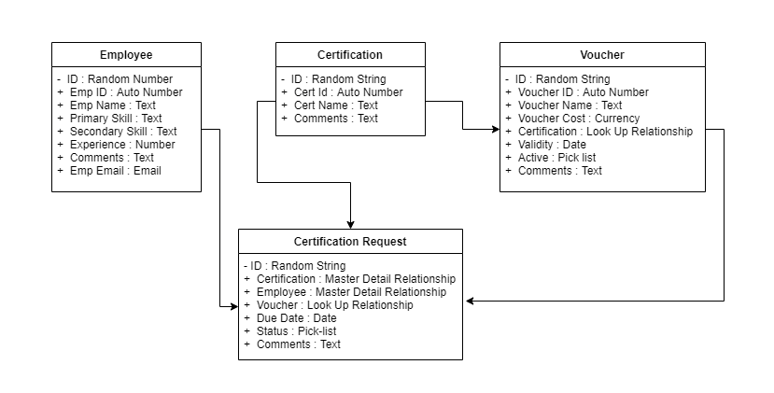

USE CASE DIAGRAM

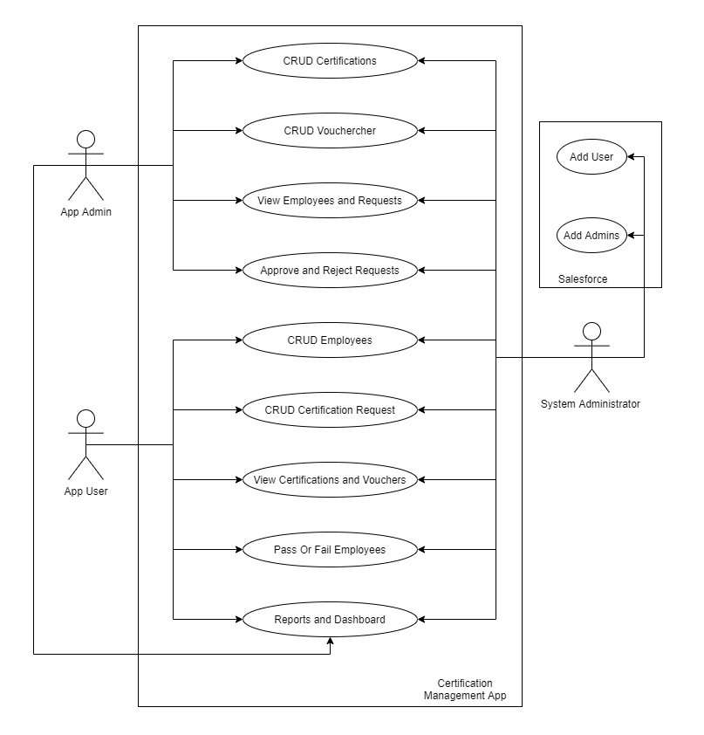 SEQUENCE DIAGRAM(App Admin)

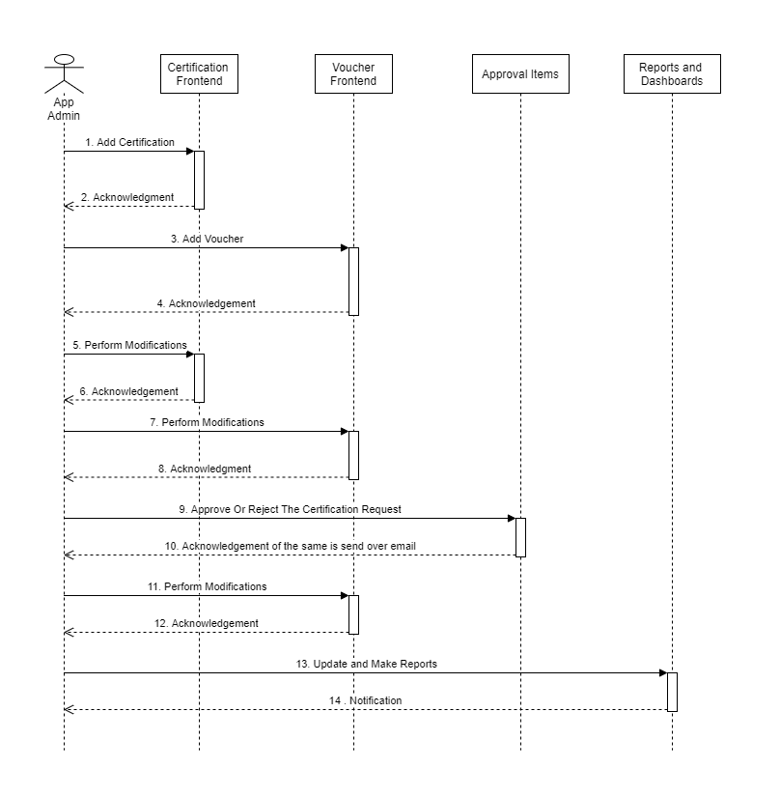

SEQUENCE DIAGRAM(App User)

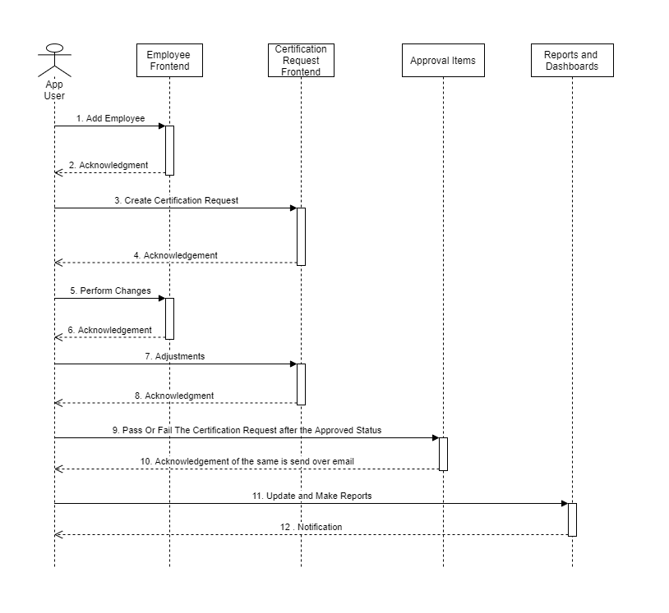

ACTIVITY DIAGRAM(App Admin)

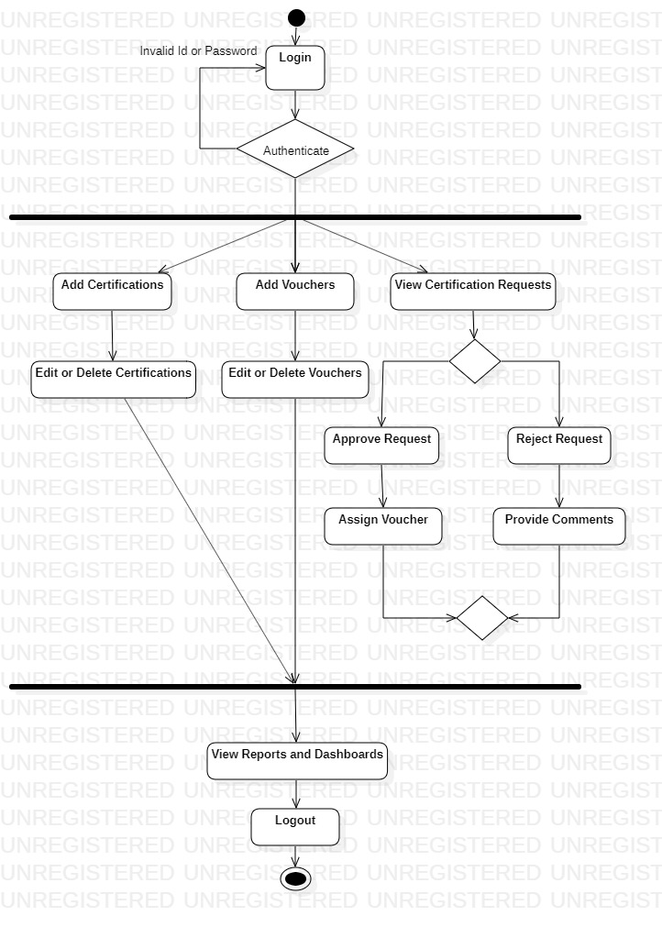

ACTIVITY DIAGRAM(App User)

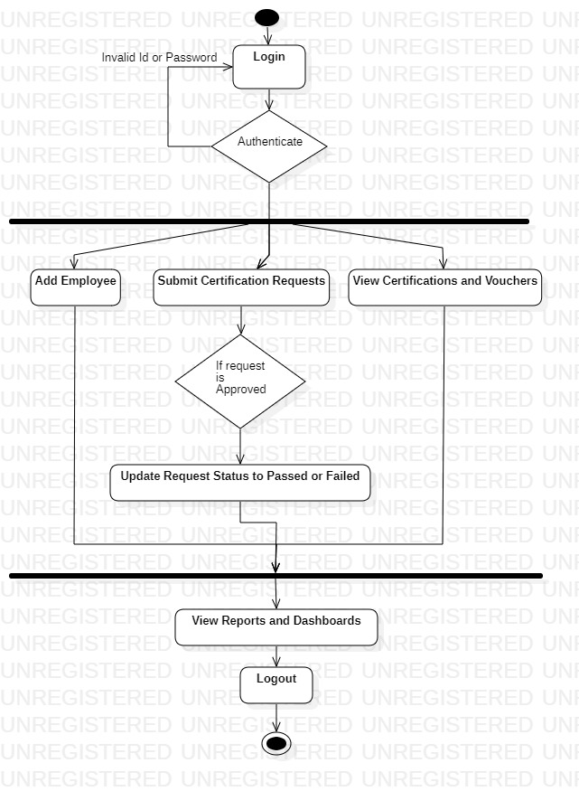

APPLICATION FLOW

* The App Admin creates a Certification for the Employees to be performed.
* Now an Employee who has to perform the Certification, mails the App User regarding the Certification he wants to apply for.
* Now the App User, creates that Employee in the Application and raises the Certification Request for the Employee taking in the Certification he wants to apply for.
* Now in this process is a voucher was available, the app user would have pre-assumingly applied for the same to the Request.
* Now the App admin can either create Certifications, vouchers as he could do before.
* Now the App Admin performs reviews over the records of the Certification Request, to check the Approval items in the records which are send to him by default.
* Now, if the App Admin, Approved the Request, then the Employee can write the exam.
* Else, if Status is et to Rejected, then the Employee cannot appear for the Certification exam.
* Once, the Employee has been approved to write the Exam, if he has no voucher applied at that moment, and there is a voucher available in the Vouchers, then it is automatically applied, in that case.
* Now after the Employee has appeared for the Examination, he passes on the details to the App User about his results.
* Now the App User updates the results accordingly in the Application.
* So, this Is the whole process and this repeats over and over again.